KiCad Installation Script Manual

Introduction
The KiCad installation script generates a single compressed executable file which contains all the files necessary to install KiCad on a Windows operating system.
The installation script allows the user to select which parts of the package they wish to install. The following files will be installed with each component.

Main application
..\AUTHORS.txt
..\COPYRIGHT.txt
..\license_for_documentation.txt
..\template\*
..\bin\*
..\internat\*

Libraries and components
..\library\*
..\modules\*

Demonstration projects
..\share\demos\*

Help files
..\doc\help\*
..\doc\tutorial\*

Updating the installation package
- Copy the NSIS script and associated files into a subdirectory of the KiCad binaries file structure (normally KiCad\NSIS)
- Open the install.nsi file with an editor Notepad or MH NIS Edit.
- Update to version numbers on line 21.
!define PRODUCT_VERSION "2006.08.28"
- Save the file then compile the installation

Checking a language translation
Most of the displayed text has been translated by NSIS and so should be correct. If this text needs editing please modify the files in “C:\Program Files\NSIS\Contrib\Modern UI\Language files”and post your modifications to the NSIS forum.
However, there is some addition text required by the KiCad script. This is stored in the language header files in the NSIS subdirectory of the KiCad binaries file structure (normally KiCad\NSIS).
The text in these files should be corrected by comparing the language file the the English version in “English.nsh”. The modified files should be saved and the script compiled.

Adding a new language
- Copy the English.nsh file and rename it with the name of your new language
- Translate the text in speech marks and change the language identifiers ${LANG_ENGLISH}
- Open the install.nsi file with an editor Notepad or MH NIS Edit.
- Add the insertmacro MUI_LANGUAGE command and include your new language file at lines 81 and 88
!insertmacro MUI_LANGUAGE "French"
!include "French.nsh"
- Save the file then compile the installation

Compiling the installation
- Install NSIS version 2.18 or later (if not already installed)
- Navigate to the NSIS directory in the KiCad binaries file structure and right click on “install.nsi”
- Select the “Compile NSIS Script” option as shown below
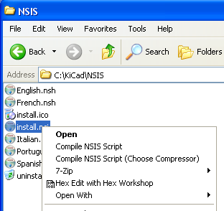
- The NSIS compiler will open and compile the script. It will then compress the package this can take a long time (up to 5 minuets on a 3.2GHz P4).

